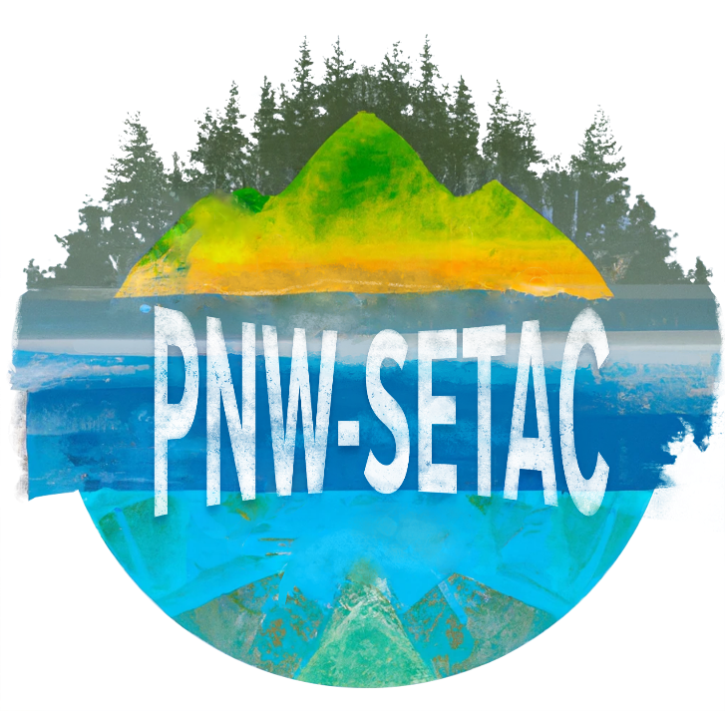
OFFICER AND MEMBER SPECIFIC DUTIES
The President shall:
1. Convene and preside over all regular and special Chapter meetings and all meetings of the Board of Directors and perform all duties pertaining to the office.
2. Sign all communications sent out in the name of the PNW-SETAC and be the spokesperson for the Chapter on all official matters.
3. Represent the Chapter at significant Society functions and conference meetings. 4. Delegate tasks as needed.
5. Appoint members to vacant positions on the Board of Directors.
6. Work closely with the Board of Directors in all Chapter administrative decisions and activities. 7. Be organized, receptive, responsive, and available.
8. Train the Vice President.
The Vice President shall:
1. Assume the duties of the President in her/his absence.
2. Assist the President in matters of Chapter administration and other duties as assigned.
3. Attend general and special meetings with the Chapter President.
4. Coordinate and oversee the Nominations and Elections of new Board members.
5. Maintain current Bylaws and Chair the Bylaws Revision Committee as needed.
6. Contact SETAC in January to obtain forms for Short Course funding. Work with Chapter Meeting Short
Course Coordinator to make sure forms are filled out and submitted to SETAC by the deadline.
7. Serve on Chapter committees as needed.
The Treasurer shall:
1. Pay any bills or debts incurred by PNW-SETAC from the Chapter’s bank account.
2. Prepare all tax statements and submit necessary forms for Internal Revenue purposes.
3. Monitor the Chapter budget, maintain current budget status reports, and provide signature authority in the absence of the Chapter President.
4. Provide a year-end budget summary to the Board of Directors and the Chapter membership at the annual meeting.
5. Oversee the administration of Membership applications, collection of dues, and notification to appropriate Directors or Chairs of member’s interest in serving on committees.
6. Maintain a current list of members.
The Communications Lead shall:
1. Record Meeting Minutes at the Chapter Board meetings and distribute copies for approval prior to the next scheduled Chapter meeting.
2. Assist the President in preparing and distributing meeting agendas prior to the annual meeting.
3. Maintain file copies of Chapter reports, meeting schedules, minutes, agendas, and attendance records. 4. Collaborate with the President and other Directors to edit, copy, and distribute all PNW-SETAC official correspondences.
4. Author Blogs and articles.
5. Use social media platforms to facilitate communication with members and other interested individuals in the Pacific Northwest region.
The Board of Directors shall:
1. Attend and participate in Chapter Board and Business meetings.
2. Contribute personal and professional expertise on issues brought before the Chapter.
3. Represent their constituent group interests in Chapter business proceedings.
4. Outreach to members of their constituent groups to encourage their participation and involvement in the Chapter.
5. Encourage constituents to involve students in the Chapter to serve on the Board, give presentations of their research, or help with the annual meetings.
6. Serve as mentors to student members.
7. Present research studies and other scientific endeavors at the annual Chapter meetings. 8. Provide the Newsletter Editor with announcements, job openings, and news items of interest. 9. Notify other Board members of potential opportunities for further outreach of the Chapter to diverse community groups.
10. Promote the Pacific Northwest Chapter of the Society of Environmental Toxicology and Chemistry. 11. Duties for specific Board of Director “at-large” positions are listed separately for the following: a) Government
b) Industry
c) Academia
d) Student
The Newsletter Editor shall:
1. Work closely with the President to promote PNW-SETAC regionally.
2. Serve as a communication liaison between the Chapter and other SETAC Chapters, agencies, special interest groups, colleagues, and the general public by publicizing Chapter events and activities utilizing all appropriate media services and the Chapter Newsletter.
3. Oversee publication of PNW-SETAC Newsletter and Chapter announcements. Send Chapter news articles to SETAC for publication in SETAC Globe newsletter.
4. Receive all written and verbal news items, announcements, and communications from the Board of Directors, committee chairs, and Chapter members.
5. Prepare written news items, announcements, and communications for publication in the Newsletter and for posting on the Chapter Web page with guidance from the other Board members.
6. Coordinate with the PNW-SETAC Web Manger to keep Web pages up to date with meeting minutes, agendas, activities, forms, Bylaws, committees, and other news items and announcements.
7. Maintain a current job board of employment opportunities and job announcements from agencies and the membership using the Newsletter, Web page, and email.
8. Serve on Chapter committees as needed.

The Web Manager (often the Communications Lead) shall:
1. Keep Web pages up to date with meeting minutes, agendas, Chapter activities, meeting registration forms, membership forms, Bylaws and Constitution, volunteer opportunities, current committees, and other news items and announcements.
2. Update the coding and web page formatting as needed.
3. Maintain the domain registration and website hosting and procure other web services for the chapter as needed.
PNW-SETAC Annual Chapter Meeting Coordinator
1. Follow Annual Chapter Meeting Guidelines and Standard Operating Procedures to plan and execute the annual Chapter meeting with the assistance of a member living near the meeting venue, as summarized below.
2. Identify potential meeting locations for upcoming Chapter meetings, including cities and specific venues. Investigate venues to determine pricing and present to the Board for selection of a location.
3. Negotiate a contract with the venue for conference rooms, audiovisual equipment, catering, and hotel rooms, as appropriate. Arrange for payment at appropriate times upon Board approval and at conference completion.
4. Present catering options and pricing to the Board for approval and finalize with the venue. Ensure that dietary restrictions and allergies are addressed.
5. Coordinate entertainment and social functions, with the assistance of the Board.
6. Program the registration website and report to the Board on registration progress at appropriate intervals.
7. Prepare the conference program with input from other volunteers and arrange for printing and delivery. 8. Prepare conference registration materials, such as name badges, ribbons, placards, etc. and ensure their
delivery to the venue. Purchase, store, and bring to the conference all other office supplies needed (pushpins, tape, raffle tickets, etc.).
9. Be present at the conference as the main point of contact for the venue, in coordination with other designated points of contact on the Board (e.g., Treasurer, Secretary, Registered Agent).
All Members shall:
1. Attend and participate in Chapter meetings.
2. Contribute personal and professional expertise on issues brought before the Chapter.
3. Bring issues from their locales and agencies of employment to the attention of the Chapter.
4. Present research studies and other scientific endeavors at the annual Chapter meeting.
5. Serve as mentors to student members.
6. Provide the Newsletter Editor with announcements, job openings, and news items of interest.
7. Notify the Board of potential opportunities for further outreach of the Chapter to diverse community groups.
8. Serve on Chapter committees as needed.
9. Promote the Pacific Northwest Chapter of the Society of Environmental Toxicology and Chemistry.
The Registered Agent shall:
1. Maintain records of all current Chapter Committees: the committee charge, minutes, goals, written reports, and name of the Chair.
2. Oversee all aspects of recruitment and appointment of Chapter members to committees as needed.
3. Maintain contact with committees. Assist Chairs as needed.
4. Oversee reporting from committee chairs to the Chapter membership.
5. Serve on Chapter committees as needed.

PNW-SETAC BOARD OF DIRECTOR - AT LARGE DUTIES
Academic
Duties associated with Meeting
1. Award travel funding to students
2. Arrange competition for the student presentations
3. Obtain books and marketing materials from SETAC NA
4. Help find sponsors as directed/decided by the board
5. Contact academic programs to encourage them to participate and attend the conference
Specifics:
1. Award travel funding to students:
a. Form a subcommittee to review student travel applications.
b. Work with treasurer to understand previous level of funding and current status of finances.
c. Propose to board the travel awards (as a total amount with important details). Excel sheet included as an example.
d. After approval by the board, contact students with award information – amount, what is and is not covered, whether receipts need to be included, how to get the award. Work with the treasurer on the questions of receipts and how to get the award.
e. Make sure the treasurer has the list of students and what they have been awarded.
2. Arrange competition for the student presentations:
a. From RegOnline https://www.regonline.com/manager/login.aspx get the list of people who have volunteered as judges. Get the username and password from treasurer or secretary.
b. Contact potential judges. The goal is to have multiple judging teams that include a representative from academia, industry, government, and a student. Depending on the number of poster and platform presentations, 4-6 groups are recommended if possible.
c. Get a list of students who indicated a preference for judging from the abstract review committee (provide them with the Excel sheet before they do their review and ask them to send it back to you, example included). Sort the students into groups that are manageably sized and appropriate. Consider the level of education and whether the presentation is a poster or platform.
d. Assign judge groups (2b) to the student groups (2c). Pay attention to affiliation (don’t assign a judge to a student with the same affiliation if possible), students should not be judges by their faculty advisers, colleagues, or students from the same program/university, and students should not judge other students in the same category they are presenting in.
e. Let judges know by e-mail that there will be judging packages for them at the conference and any other relevant information.
f. If you need more judges, as the conference sate gets closer watch for new registrants (government and academics seem to register later than industry). E-mail and ask for their help to round out your judging teams.
g. The judging packages should include: score sheets for all of the students they are judging, instructions for how to judge, a list of the other judges, and list of the students they are judging. Examples included.
h. You are the tiebreaker if needed, otherwise, don’t participate in judging. Be available to guide judges as they make final award selections. Work with the treasurer to understand the award budget and help the judges understand the number of awards they should have. With a smaller conference, expect less awards.
i. Announce award winners at the end of the conference. Check with the president to see how they want to wrap the conference up since you are the last presenter. Remember to thank the judges, encourage others to help out in the future, and thank the students. Don’t let students leave the front of the room until all the awards have been given out so we can get a group picture of the winners. Coordinate with the photographer.
j. Write up a short paragraph for the newsletter about the winners. Coordinate with the secretary responsible for the newsletter on deadline.
3. Obtain books from SETAC - NA:
a. Contact Person changes. Please contact the office. The contact will share a list of available books in early February. You select the books you want and send it back.
b. The SETAC-NA contact will send you the books prior to the conference. You take them to the conference and find a display table for them. Put them out early in the conference, preferably in the platform presentation room so they aren’t unattended.
c. At the end of the conference (during the awards presentations), give students the opportunity to get a book of their choice. One suggestion is a tiered approach where all student presenters get first choice, then student volunteers, then all other students.
Government and Industry
1. Promote the Pacific Northwest Chapter of the Society of Environmental Toxicology and Chemistry 2. Develop a sponsorship strategy in relation to the topic and location of the Meeting
3. Notify other Board members via a Master list
Specifics:
1. Promote the PNW-SETAC meeting
With the updated list of PNW-SETAC member, the At Large Industry representative will promote the PNW-SETAC Meeting to consultant companies, industries, non-profit organization, etc…, via phone, email, personal meeting during the previous year of the meeting. The president should be cc’d into the emails communication. The purpose of each communication should be to obtain sponsorship, encourage participation and/or attend the conference.
2. Develop a strategy
With the help of the board, the representative determines which specific industrial sector should be contacted in relation to the specific scientific topic exposed at the upcoming Meeting. Local industry should be targeted as marketing impact will be a positive feature for the company sponsoring.

3. Notify other Board members
A list of previous sponsors and future potential sponsor should be maintained by the representative and distributed to the Board members. Each board member will update the list as they contact their own potential sponsors. The contact on the Master list will be shared upon the Board member to divide the communication effort.
Student
1. Serve as a liaison between the Pacific Northwest Chapter of the Society for Environmental Toxicology and Chemistry (SETAC) and its student members for academic, social, and promotional matters
2. Promote the Pacific Northwest Chapter of SETAC, particularly among students through promotion of society membership and conference attendance/participation
3. Be the primary contact for student questions/concerns regarding PNW SETAC membership and annual conference matters
4. Represent PNW-SETAC on the NASAC Board of Directors
5. Provide support to the PNW-SETAC Chapter by assisting with the planning and organization of volunteers at the annual conference
6. Contact, organize and schedule volunteers (including students) for the registration desk, timing, and poster set-up/take-down duties during the annual conference
7. Schedule PNW-SETAC board members and officers for shifts at registration desk during the annual meeting

